Exploration report: Plant recognition project

- Introduction:
The goal of the exploration report is to get an understanding of the dataset for building an effective model, preferably the CNN model with Keras.

Our scope is working with plant images which are healthy (14 plant species) and those which are sick with a type of plant disease (20 plant diseases).

- Data Overview:

We work with a database called ‘New Plant Diseases Dataset’ which is a public repository available on Kaggle.

It includes multiple subfolders; Train, Valid and Test. These subfolders contain subfolders per plant where the target image files (jpg) are stored, totalling 87,900 images.
Number of folders in train_path: 38
Files in train_path: 70,295
Number of folders in valid_path: 38
Files in valid_path: 17,572
Number of files in test_path: 33 +
Total files: 87,900

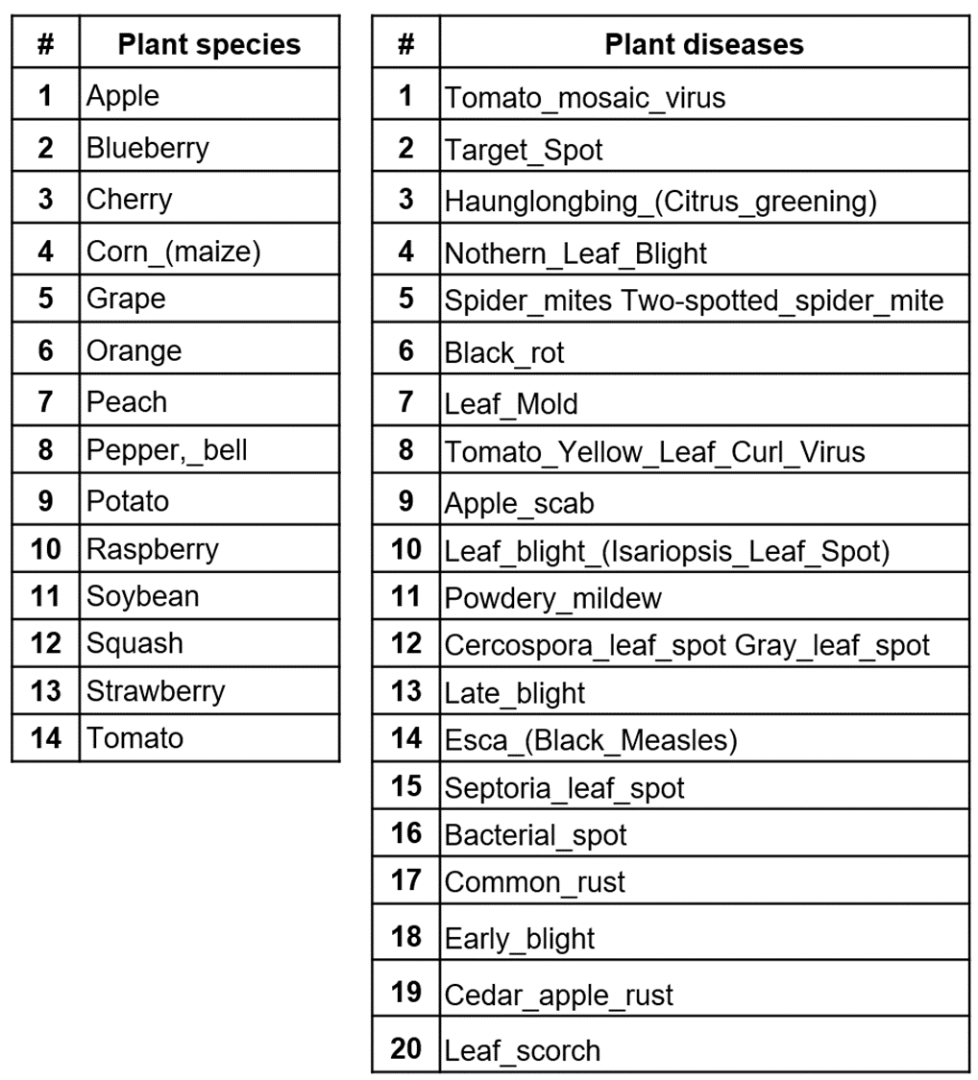
List plants and plant diseases:

- Dataset Analysis/Visualization:

- Examples of the healthy dataset:
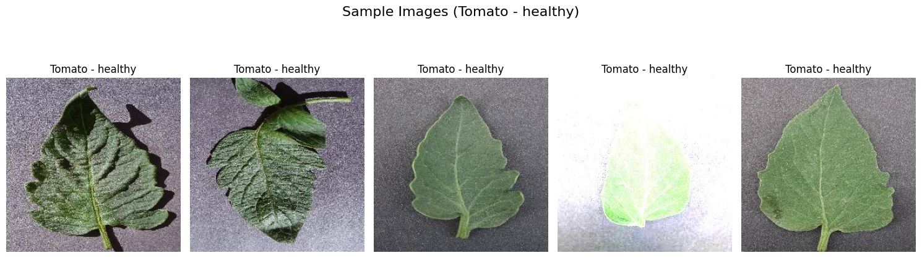

- Examples of the diseases dataset:
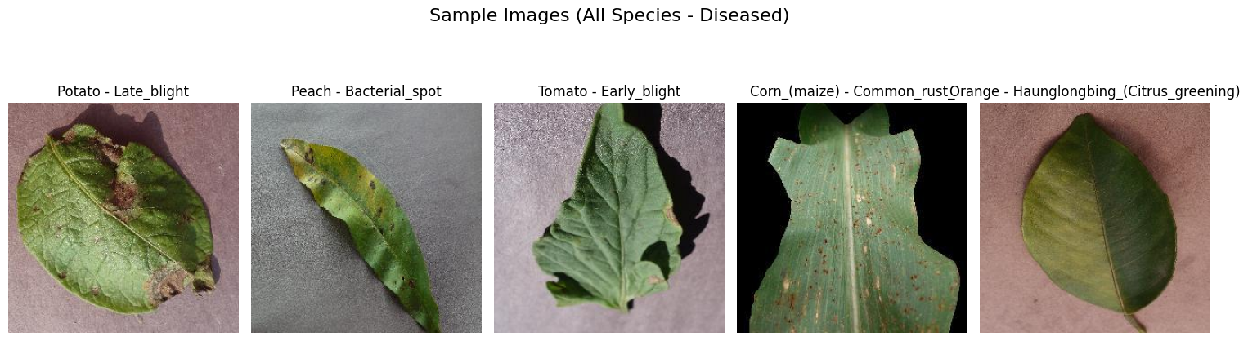

Observation: We can see that the images have been augmented already to enrich the training and valid datasets.

- Data dimensions:
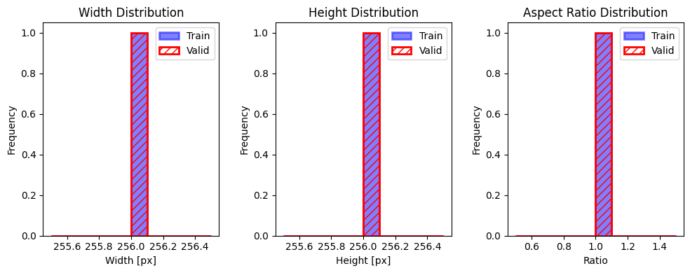
Observation: All images in the training and validation subset have the same width and height (256x256).

- RGB color channel distribution:
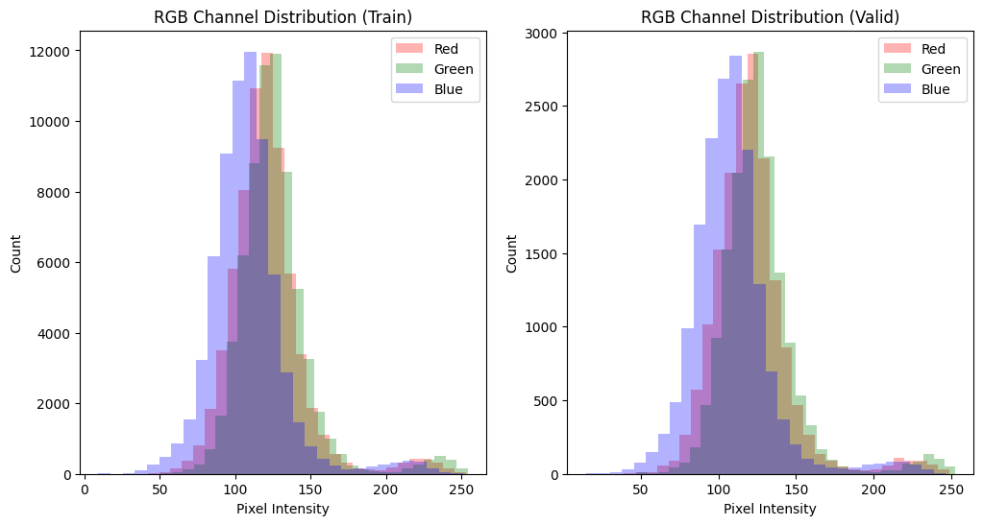

Observation: The distribution of color channels (RGB) between training and validation images is very similar, with a tendency towards the green, due to the information of the leaves from the plants.

- Distribution analysis of species:

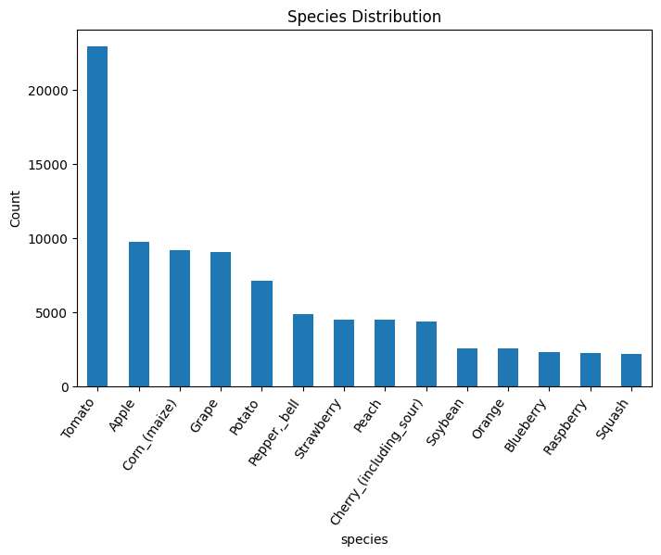
Observation: We see a higher number of Tomato images. This can have a biased impact training the model, because the model can treat tomato-related diseases for other leaves, because the other species are underrepresented in the training data.

- Distribution analysis of diseases:
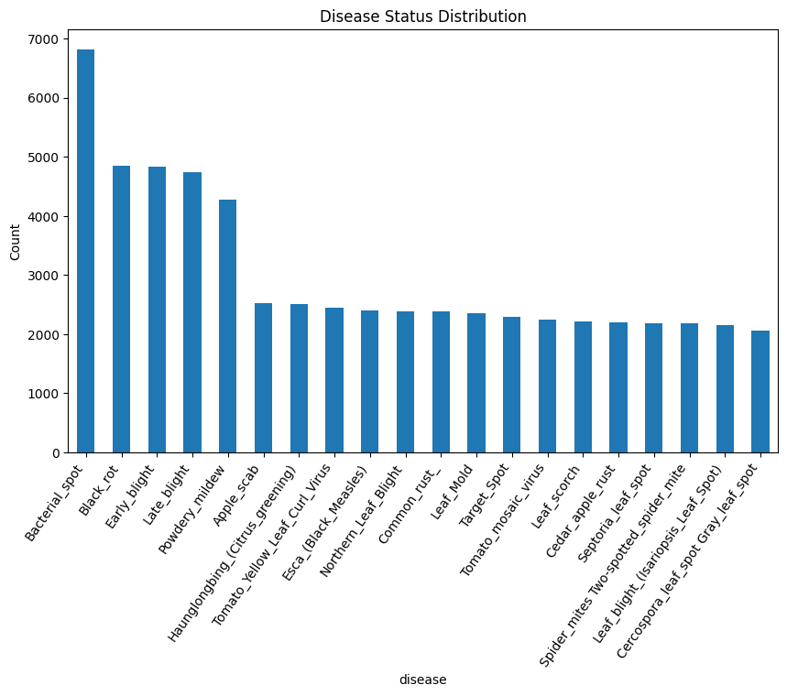
Observation: Bacterial spot is the disease with the most images in the disease dataset, but we feel that overall the distribution of the diseases are well-balanced. The top 5 diseases could be there due to the commonality of these diseases.

- Distribution between train and valid:

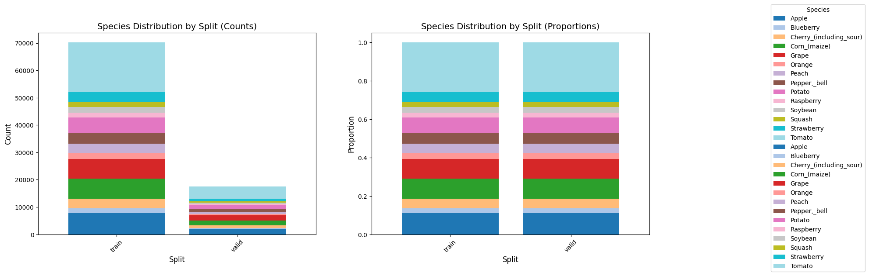
  - Species


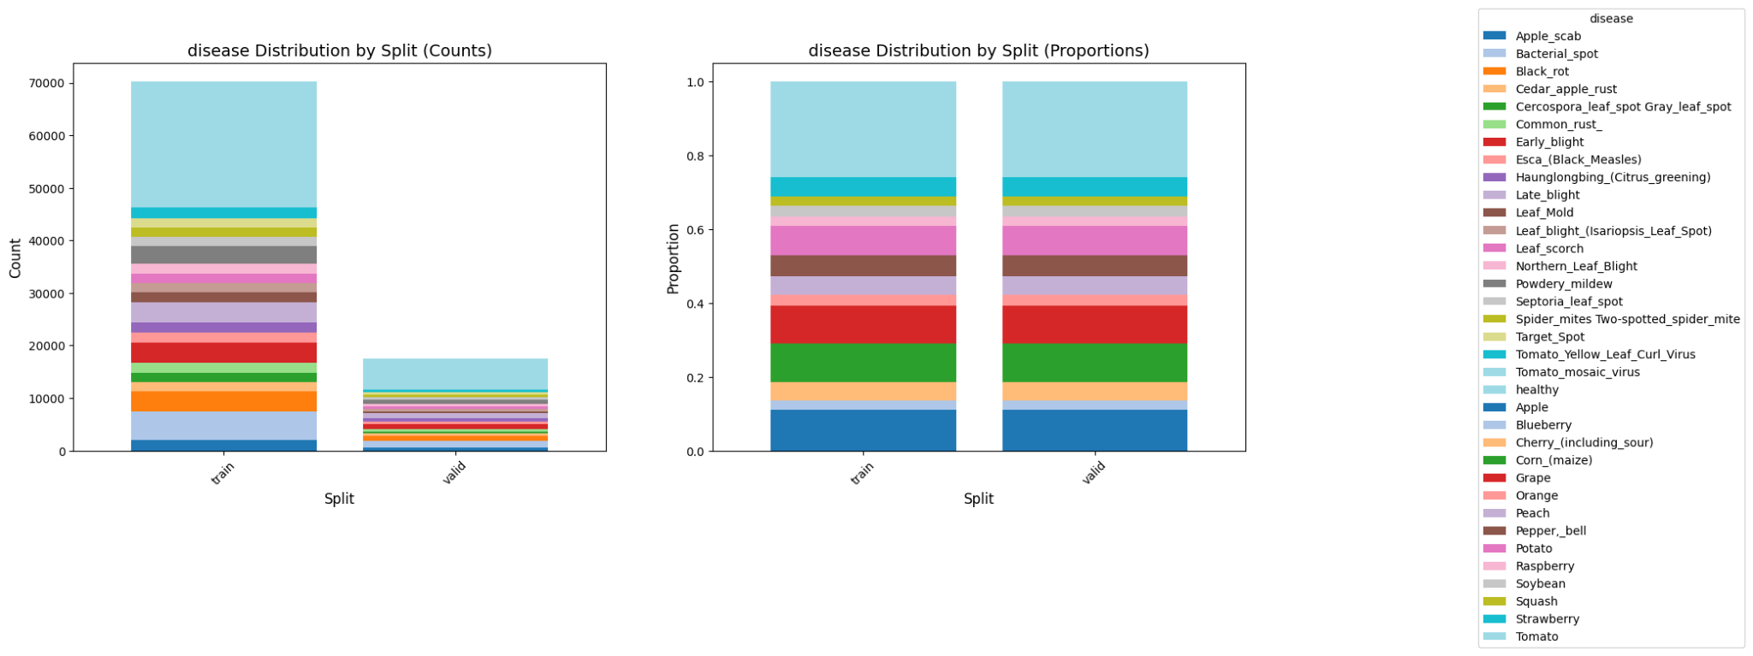

  - Disease

Observation: The Valid set contains a subset of the whole plant_set dataset with the same proportions on each category as for the Train set.

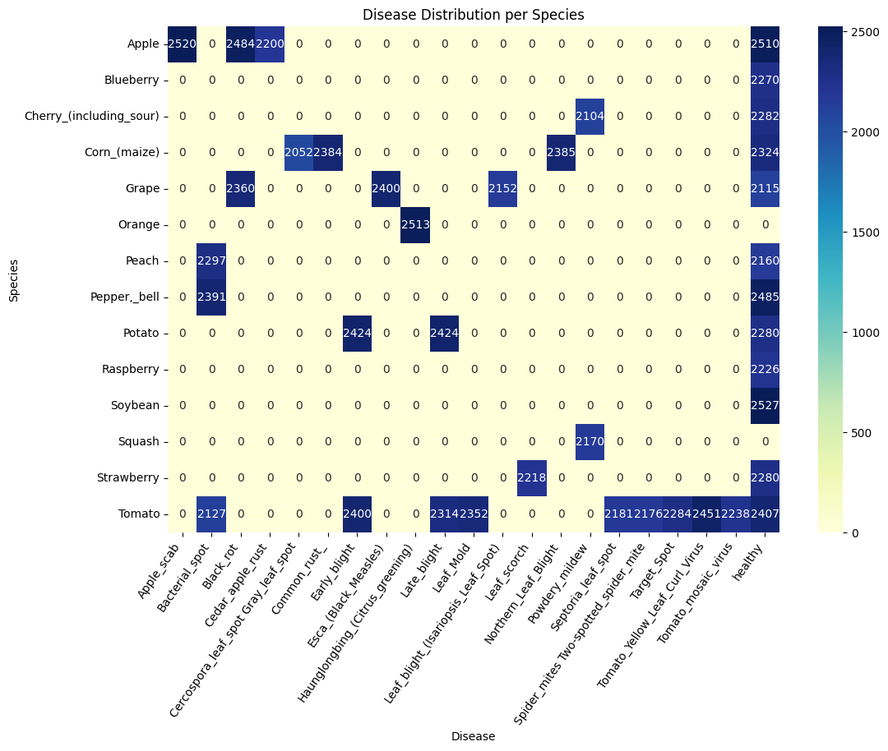
- Confusion matrix

Observation: From the confusion matrix, we can conclude that there are species that only contain healthy datasets and others that only contain data from the diseased category. These class imbalances could potentially lead to overestimations of the majority class. Especially for those plant types which only contain one disease class (e.g. Blueberry, Orange, Raspberry), we should think about ways to decrease the imbalance.

Two possible ways would be:
1. Add images of other classes to the dataset or
2. Use pre-trained models on similar but bigger datasets (transfer learning).

- Overall health vs disease distribution:
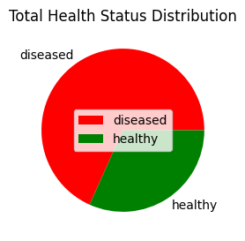
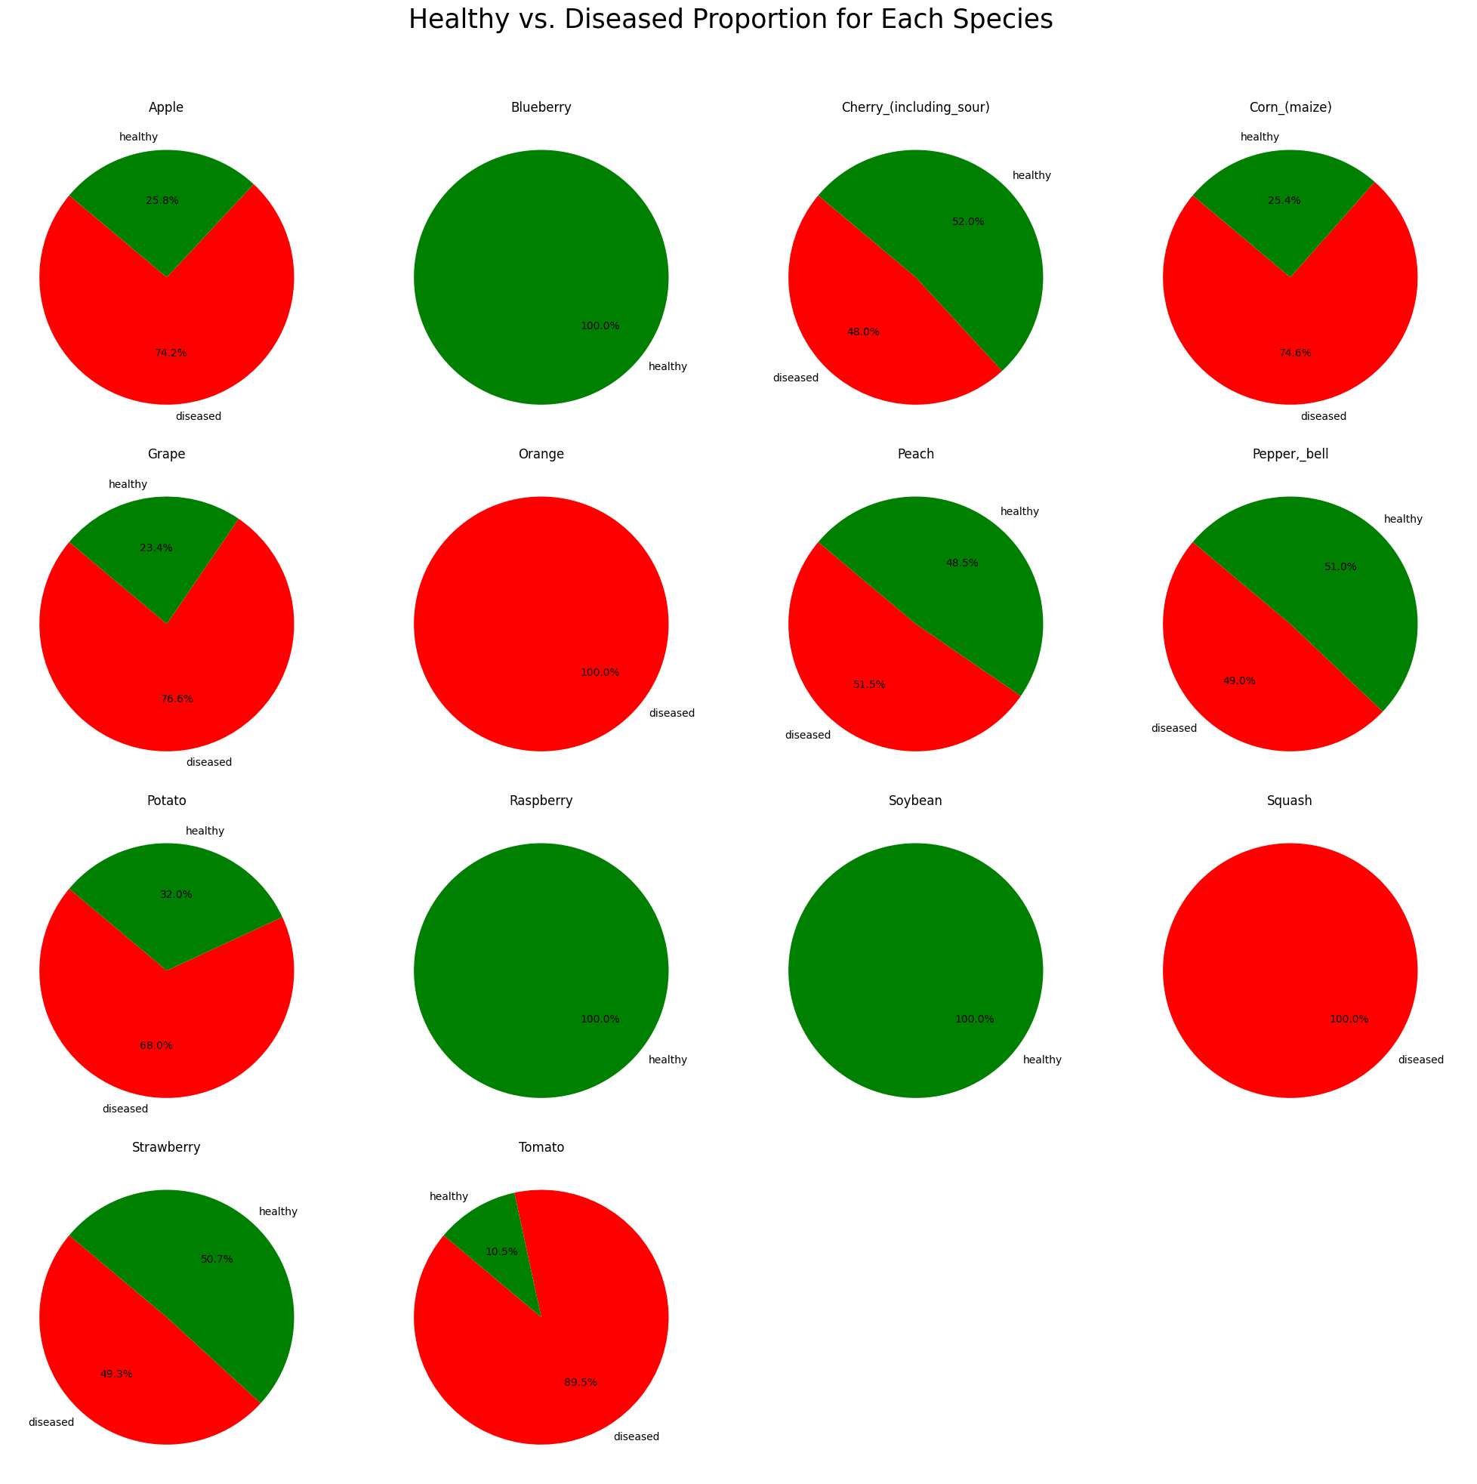
- Health vs disease distribution by species:

- Data Preprocessing:
As for the preprocessing phase we followed these steps to get to the analysis and visualisation phase of the files:
1.1 Import kaggle hub and download dataset.
1.2 Define the paths.
1.3 Importing necessary libraries for data processing and visualization.
1.4 Creating a DataFrame with Train and Valid.
1.5 Check for missing values and duplicates between train and valid subset.
The data was already well sorted, indexed and labelled. We only had to create an import path and created lists to work of from:
# Initialize lists
image_paths = []
species_labels = []
disease_labels = []
dataset_split = []
We looked for missing values and duplicates even crosschecked between the train and valid folders and found none.

- Data Augmentation:

From the samples and our own manual file checks, we can see that the images have been augmented already to enrich the training and valid files in their respective folders.

We do not exclude that any future augmenting may still be needed depending on the first model's results.

- Data Transformation:

Filtering techniques can help us extract extra information from images, like detecting certain patterns, as well as simplify the modelling, by removing noise or applying masks to reduce the amount of information to be processed.
Here are two examples of image transformation:
- Thresholding (threshold=90, max value =255)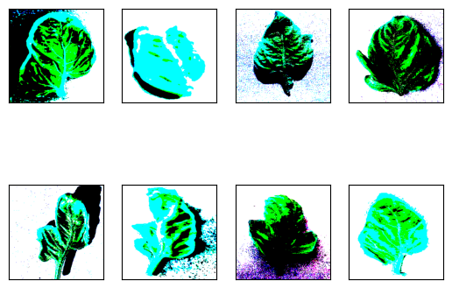

Observation: The thresholding detects light gradients, due to the direction of the light in the image. When there are different lighting conditions in different areas, adaptive thresholding might be more appropriate. In some cases, the simple thresholding is capable of removing the background, leaving only the area of the leaf in color.

- Canny filtering (min threshold= 100, max threshold=200)
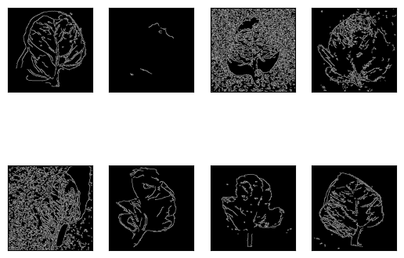
Observation: The Canny filtering is capable of detecting the edges of the leaves in some cases. This could be helpful to reduce the data and see if the model is still performing good enough while the execution time should be dramatically decreased.

- Final Observations & Considerations:

All 87,867 images in the training and validation subset have been augmented and are of the same width and height. The distribution of color channels (RGB) between the images is very similar, with a tendency towards the green. The overall train vs valid proportions are perfectly balanced 50/50 whereas the classes of species and diseases are well-balanced, but not perfectly balanced.

We need to consider that we see a high number of healthy Tomato images which could cause a biased impact on the training model.

Another consideration is that there are species that only contain healthy datasets and others that only contain data from the diseased category. These class imbalances could potentially lead to overestimations of the majority class.
- Next Steps:
We are left with a few open questions which we will only answer once we start with the modelling phase.

- Will the models be capable of detecting those plants/diseases which are absent in the train and validation dataset?
  - For example for the diseased oranges and squash images, will the model be able to identify a healthy orange and/or squash?
  - Vice versa, for the healthy raspberries, blueberries and soybeans images, will the model be able to identify diseased images of raspberries, blueberries and soybeans?

The images in the test set belong to the following plant species:

# | Plant species
1 | Apple
2 | Corn
3 | Potato
4 | Tomato

These four species all contain a mix of healthy & diseased examples in the train/valid sets. Therefore, this test set might not be suitable to measure the model performance when it comes to the question of detecting absent classes (e.g. healthy oranges or diseased blueberries).
- We should think about how to decrease potential imbalances?
Some ways would be:
  - By adding images of other classes to the dataset or
  - To use models pre-trained on similar but bigger datasets (transfer learning).
  - Use Class weights
  - Oversample the minority classes
  - Undersample the majority class.

How do we go from here?
Our approach is that all members in the project group ‘Planting Parents’ have their own G-Colab notebook with which they can experiment on the models.

We all maintain the same master code as of the data exploration phase.

We will discuss weekly in our team meetings what discoveries have been made by each member individually and what we would like to implement into the master code.

END

Please reach out to us if you have any questions or other remarks.
The Planting Parents,
Lara, Yannik, Ji-Young and Niels

